**UVSim Main Window**

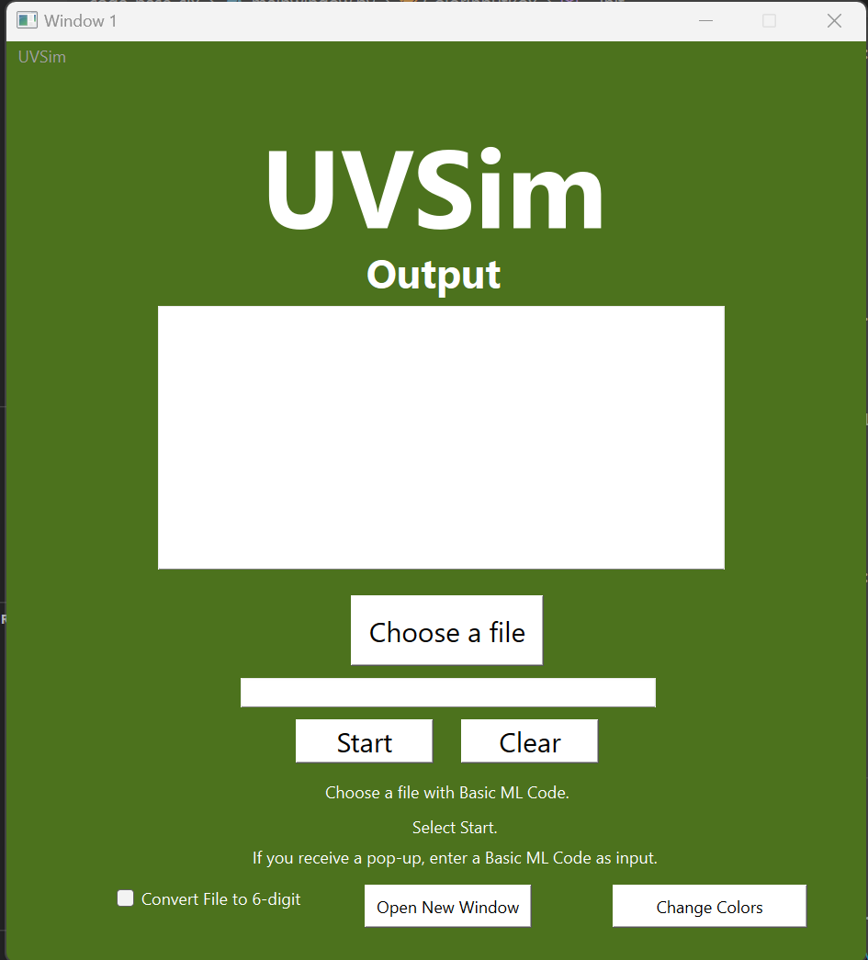

**This page includes:**

* **Title Text:** The title shows the UVSim title so the user knows they are using UVSim. **Output Box:** This labeled box displays the output produced from running the file.
* **Choose File Button:** Clicking this button allows the user to select a file from the user’s system for UVSim to run.
* **File Name Box**: This box shows the name of the file the user selects.
* **Start Button**: Clicking this button allows the UVSim to run the code from the file given by the user.
* **Clear Button**: Clears the program for the user to start fresh.
* **Change Colors Button**: Opens the pop-up for the user to change the colors of UVSim. (See Below)
* **Instructional Text:** There is text just above the bottom center of the page that tells the user what they need to do in order to use UVSim.
* **Convert File Check-Box**: The convert file check-box lets the user decide if they will be using a 4 or 6 digit file. If the box is checked then the file will be converted to 6 digits and will appear that way in the pop up as well.
* **New Window Button**: The new window button opens another UVSim window so that the user may edit multiple files at once and run them separately.
* **Close Button (X):** This button allows the user to halt execution and close UVSim.

**Change Colors Pop-Up Box**

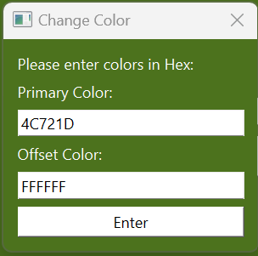

**This Pop-Up Includes:**

* **Informative Label**: The label tells the user to “Enter a Color in Hex”, this helps explain to the user what they need to do.
* **Primary Color Text Box (with label):** This box allows the user to enter a hex value for the UVSim to use as its’ primary color.
* **Offset Color Text Box (with label):** This box allows the user to enter a hex value for the UVSim to use as its’ primary color.
* **Enter Button:** This button applies the colors given in the text boxes to UVSim, closes the pop-up, and returns the user to the program.
* **Close Button (X)**: This button allows the user to close the pop-up and return to UVSim without updating the colors.

**Input Pop-Up**

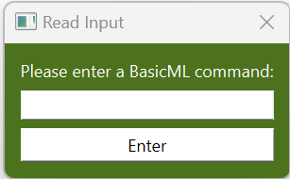

**This Pop-Up Includes:**

* **Informative Label**: The label asks the user to enter a BasicML command, this helps explain to the user what they need to do.
* **Text Entry Box:** This box allows the user to give input of a line of BasicML code.
* **Enter Button:** This button will load the given input into the UVSim for use in the program.
* **Close Button (X):** This button will make the pop-up close but the program will continue execution using “0” instead of a user-inputted value. The program may not run as expected since “0” is not in BasicML format, but the program will not crash.

**File Editor Pop-Up**

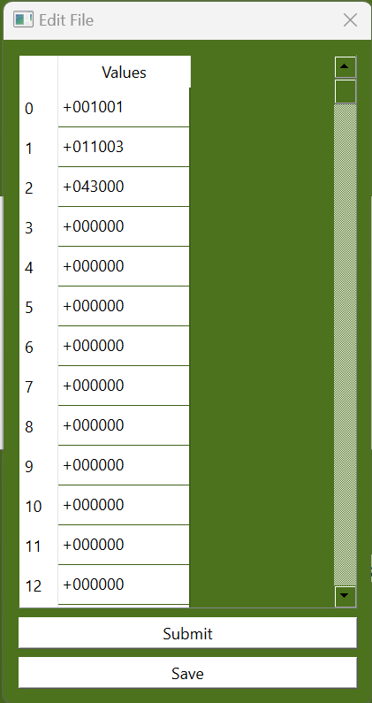

**This Pop-Up Includes:**

* **Values Bank:** The values bank has 250 boxes for the user to input the BasicML code. The Values bank is numbered for the convenience of the user
* **Scroll Bar:** The scroll bar allows the user to scroll up and down in the pop-up to view and edit code with ease.
* **Submit Button:** This button will load the edited file into the UVSim for use in the program.
* **Save Button**: This button will prompt the user to save the edited file in their computer.
* **Close Button (X):** This button will make the pop-up close and the program will not run until further instructions are given.